LOGO | Company Nam

Master Glossary
Software Requirement Specification

Project Code: GCS
Document Code: GCS_SRS_MasterGlossary_v1.2

Ha Noi, Jun- 2008
Record of change

*A - Added M - Modified D - Deleted
Effective Date | Changed Items | A*  M, D | Change Description | New Version
10-Jun-08 |  | A | Create the first version | 1.0
22-Jun-08 | 5 Appendixes | M | Added the following sub sections  - Common Message Description  - Classes of IMO  - Repairing Equipment & repairing resources | 1.1
22-Jun-08 | 3.1 Main Functionalities  3.2 Common Functionalities | A | Added some common functionalities | 1.1
22-Jun-08 | 2.4 Entity Diagram  2.5 Entity Details | M | Refined entity attributes and entity name of all entities | 1.1
29-Jun-08 | 4.1 System Through Put | M | Updated the number of transactions | 1.2
29-Jun-08 | 4.5 Design Constraints | M | Updated requirements for designing page size, Modularity, others. | 1.2
29-Jun-08 | 4.10 Archive & Purging  4.8 Scalability | A | Added requirements for Archive & Purging  Added requirements for scalability | 1.2
29-Jun-08 | 4.3 Performance Requirements | M | Updated data volume section, response time, and availability | 1.2

SIGNATURE PAGE

ORIGINATOR: Nguyen B 25 Jun 2008

REVIEWERS: Nguyen A 28-Jun-08

Nguyen Son

APPROVAL: Nguyen Sang 29-Jun-08

Falak

Shaik Ali

Narasimhan

TABLE OF CONTENTS
1 Introduction 7
1.1 Purpose 7
1.2 Document Scope 7
1.3 Definitions, Acronyms, and Abbreviations 7
1.4 Business terms 8
1.5 References 9
1.6 Document Overview 10
2 Overall Description 11
2.1 System Overview 11
2.2 Core Business Process 11
2.3 Project scope 14
2.4 General Business Rules 15
2.4.1 Cargo Item Status 15
2.4.2 Export Booking Status 16
2.5 Security Matrix 16
2.6 Constraints 16
2.7 Assumptions & Dependencies 16
3 Logical Database 18
3.1 Entity Diagrams 18
3.2 Entity Details 19
3.2.1 User Group 19
3.2.2 Shipping Agent 20
3.2.3 Shipper 20
3.2.4 Address 20
3.2.5 Export Booking 21
3.2.6 Shipping Note 21
3.2.7 Cargo Item 22
3.2.8 Loading List 23
3.2.9 Location 23
3.2.10 Slot 24
3.2.11 Vessel 24
3.2.12 Shipping Line 24
3.2.13 Berth 25
3.2.14 Berth Booking 25
3.2.15 Berth Plan 26
3.2.16 Gear 26
3.2.17 Port 26
3.2.18 Hold Record 27
3.2.19 Customer 27
3.2.20 Import Booking 27
3.2.21 General Reference 27
3.2.22 Repairing Request 28
3.2.23 Cargo Condition Record 28
3.2.24 Storage Order 29
3.2.25 Cargo Item List 29
3.2.26 User 30
3.2.27 Stack 30
3.2.28 Row 30
3.2.29 Block 30
3.2.30 Location History 31
3.2.31 Repair Resource 31
4 Functionality Description 32
4.1 Main Functionalities 32
4.2 Common Functionalities 32
4.2.1 UC C1.1 Search Vessel 32
4.2.1.1 Actors 32
4.2.1.2 Pre-condition 33
4.2.1.3 Mock-up Screen & Data Fields 33
4.2.1.4 Main flows 33
4.2.1.5 Alternatives flows 34
4.2.1.6 Business rules 34
4.2.2 UC C1.2 Search Shipping Agent 34
4.2.2.1 Actors 34
4.2.2.2 Pre-condition 34
4.2.2.3 Mock-up Screen & Data Fields 34
4.2.2.4 Main flows 35
4.2.2.5 Alternatives flows 36
4.2.2.6 Business rules 36
5 NON-Functional Requirements 37
5.1 Availability 37
5.2 Supportability 37
5.3 Performance Requirements 37
5.3.1 System Throughput 37
5.3.2 Response Time 37
5.3.3 Data Volume 38
5.4 User Interface 39
5.5 Design Constraints 39
5.5.1 Date/Time Format 39
5.5.2 Number Format 39
5.5.3 Multi Language 39
5.5.4 Auditing 39
5.5.5 Page size 39
5.5.6 Modularity 39
5.5.7 Others 39
5.6 Usability 40
5.7 Reliability 40
5.8 Scalability 40
5.9 Security 40
5.10 Archive & Purging 40
5.11 Hardware/Software Requirements 40
5.12 Purchased Components 41
5.13 Bugs and Defect Rates 42
6 Appendixes 43
6.1 Common Message Description 43
6.2 Classes of IMO 43
6.3 Repairing Equipment List 44
6.4 Repairing resources (people) 44

Introduction

Purpose
This document aims at describing the general requirements, non functional requirements, and general section of SRS package of GSC system.
By using this document, project team, business support team and the other people can have an overview about the software requirement specification of the GCS application and business/power users can review this document to know how the requirements have been documented. This document also describes the requirement scope of each phase in the project.

Document Scope
This document only describes all general requirements and non functional requirements of GCS system. It does not include the detailed requirements for all processes of the system

Definitions, Acronyms, and Abbreviations
Term | Description
Shipping Agent | Cargo Operator, Freight Forwarder
GC Officer | General Cargo Officer
BRN | Booking Reference Number
MDS | Manifest and Document System
CTS | Container Management System
ETA | Estimated Time of Arrival
EP | Export Processes
IP | Import Processes
IMO Class | IMO Class for dangerous goods.
UN | Classification of dangerous goods  For all modes of transport (sea, air, rail, road and inland waterways) the classification (grouping) of dangerous goods, by type of risk involved, has been drawn up by the UNITED NATIONS Committee of Experts on the Transport of Dangerous Goods (UN).
DT | Dubai Trade Portal
E/D | Export Declaration number
TBA | To be advice
B/L, BOL | Bill of Lading
BOA | Berthed On Arrival. A vessel is considered BOA if the Delay is less than a previously agreed value.
BOE | Bill of Entry
BTR | Berth Time Requested. This is the expected arrival time of a vessel
BRN | Booking Reference Number
CFS | Container Freight Station
Crane Intensity (CI) | Specifically related to the quay cranes, it is a measure of the number of containers that can be handled by a crane in an unit of time.
DO | Delivery Order
DDC | Direct Delivery Cargo
DPA | Dubai Port Authority
DPC | Documentation Processing Charges
Draft | The height of water table measured in meters.
EA | Export Application. EA number is also known as Booking reference.
EB | Export Booking
EBI | Export Bill
ETA | Estimated Time of Arrival
ETB | Estimated Time Berthing
FCL | Full Container Load. This term is used when you the customer wishes to send a Full Container Load. There are 20' and 40' containers available and sometimes without any additional charges depending on the freight line a customer can use a high cube. High cube means a container is just a little higher and gives you the customer more room without having a book an extra container.
IDC | Import Delivery Container
IDG | Import Delivery of General Cargo
LCL | Loose Container Load. This term is used when you the customer wishes to send a lesser amount than a Full Container Load
Line | A shipping line
MDS | Manifest & Documentation System
MRN | Manifest Registration Number
NOC | No Objection Certificate
PRC | Port Receiving Charges
SN | Shipping Note
SO | Shipping Order
SKU | Stock Keeping Unit Code
TEU | Twenty-foot Equivalent Unit. This is the standard unit for measuring the container volume. Standard containers are 20 feet, 40 feet and 45 feet long.
EB | Export Booking
IMO | International Maritime Organization

Business terms
Term | Description
Activity | An activity accommodates a certain class of vessels and uses certain consecutive sections
Ageing Cargo
Allocation | A possible set of active activities
Auction Cargo
Berth / section | A small portion of the wharf. A wharf or section may be created due to restrictions on crane availability, draft etc... or simply for ease of management.
Berth Template | A solution to the Home berth allocation problem. A berth template provides the 'ideal' berth locations for a set of vessels.
Throughput | A measure of the number of vessels or containers handled over a period of time.
Vessel | A ship
Vessel Closure | Show that vessel has loaded cargos and everything is ok
Vessel Delay | The time elapsed between when a vessel arrives at the port and when the vessel is moored at the berth.
Vessel Throughput | A measure of the number of vessels handled over a period of time.
Wharf | A Linear stretch of the terminal where vessels can moor.
Yard | Location where containers are temporarily stored.
Yard Crane | Cranes used in the yard to load or unload containers onto or from prime movers
Prime movers | Vehicles used for transporting containers.
Quay Cranes | Cranes used along the quay side to load or unload containers onto or from vessels. Many varieties of quay cranes may be available i.e. Long cranes, Tall cranes etc... and should be deployed depending on the vessel type
Scheduling policy | Dictates which allocation to use at any given time
Section | Smallest unit of space
Export Back Order | Reversal of cargo sent to the port for cases where the exporter decides to take back the cargo
Connectivity Cost | A measure of the effort expended in handling containers within the terminal
Container Throughput | A measure of the number of containers handled over a period of time. This is a standard measure for the productivity of a port and is measured in terms of TEU's
Crane Intensity (CI) | Specifically related to the quay cranes, it is a measure of the number of containers that can be handled by a crane in an unit of time.

References
No. | Reference document name
1 | PROMIS_BRS_VO.GB_BerthPlanningGeneralCargo_L2_V1.3.doc
2 | PROMIS_BRS_VesselDischargeLoadOperationGC_L2_V1.4.doc
3 | PROMIS_BRS_VA.MA_VesselArrival_MA_Level2-Ver1.0.doc
4 | PROMIS_BRS_VesselArrivalNotification_L2.doc
5 | Load-DPW-VOP-GEN-003- Rev 3.doc
6 | PROMIS_SRS_VO_GY_V02.doc
7 | PROMIS_SRS_VO.GY_V.1.doc
8 | PROMIS_SRS_VO.GO_V1.0 (final).doc
9 | PROMIS_BRS_VesselArrivalNotification_L2.doc
10 | PROMIS_BRS_ImportAuthorization_L2 v1.0.doc
11 | PROMIS_BRS_ExportCargoReceiving_process_L2_Final.doc
12 | PROMIS_BRS_ExportAuthorization_L2.doc

Document Overview
This document includes following sections:
- 1. Introduction: Overview of purpose, scope, and reference information of this document
- 2. Overall Description: Describe the overall of the whole system
- 3. Logical Database: Describe the logical entity relationship and description of entity attributes.
- 4. Functionality Description: Describe the detailed functional requirements of the system
- 5. Non-Functional Requirements: Describe the non-functional requirements that the system should meet
- 6. Appendixes: Describe all general format, templates… to be used in the system

Overall Description

System Overview

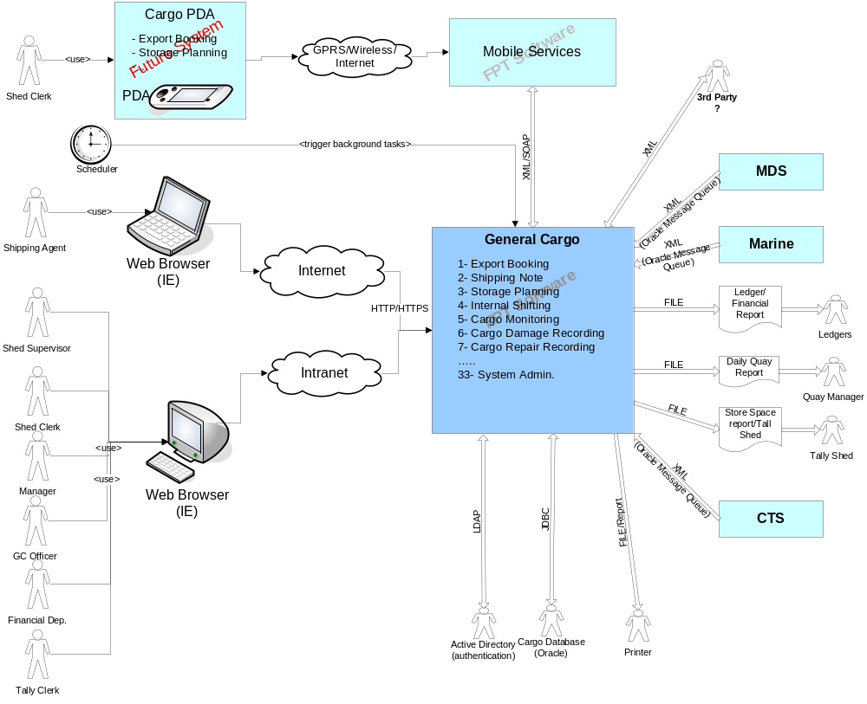

Figure 1: System Overview

<Description of System and the external integrated systems>

Core Business Process
The General Cargo System will have the following main functionalities. It will be developed in Java Web application.

Process name | Use Case Name | Use Case Description
Export Processes
Export Booking | Create Export Booking | Allow Shipping Agent to create an Export Booking in GCS
Export Booking | Update Export Booking | Allow Shipping Agent to update an Export Booking which has not been approved.
Export Booking | Search Export Booking | Allow GC Officer and Shipping Agent
Export Booking | Auto Update Export Booking | The system auto updates Export Booking from indirect loading to direct loading at cut off time if no cargo is received.
Export Booking | Generate Report | Allow the user to get statistics of Export Booking
Shipping Note | Add Shipping Note | Allow the user to create shipping notes for an approved Export Booking
Shipping Note | View Export Booking | Allow the user to view detailed information of an Export Booking
Shut Out | Create Shut Out | Allow the user to create Shut Out when he/her consolidates cargo items before Cargo is loaded to Vessel
Shut Out | Generate Report | Allow the user to get statistics for Export Bookings which has been shut out
Consolidation of Cargo | Notify Consolidation | The system notify Shipping Agent when the cut off time of Export Booking is 48 hours
Consolidation of Cargo | Search Consolidation | Allow the Shipping Agent to search all the Export Booking of a Vessel which has cut off time = 48 hours
Consolidation of Cargo | Notify Re-Consolidation | The system notify Shipping Agent & GC officer when the cut off time of Export Booking is 24 hours
Consolidation of Cargo | Re-Search Consolidation | Allow GC Officer to search all the Export Booking of a Vessel which has cut of time = 24 hours
Internal Shifting & Loading List | Manage Loading List | Allow Shed Clerk or Shed Supervisor manage shed loading list of Cargo
Internal Shifting & Loading List | Create Loading List | Allow GC officer to create loading list for Cargo
Internal Shifting & Loading List | Search Loading List | Allow Shipping Agent to query Loading List of Cargo
Internal Shifting & Loading List | Generate Loading List | Allow the user to print the loading list of Cargo to prepare for loading cargo to Vessel
Internal Shifting & Loading List | Manage Loading List | Allow the user to view/update an available loading list
Storage Receive | Cargo Receive Recording | Tally Clerk can validate Storage Receipt based on information from:  - Export Booking  - Storage Planning for intended location of cargo items  - Master Data for the actual location of cargo items.  The activity of storage receiving can be taken by use of handheld device in the future. Recorded information of cargo and storage can be generated in forms of reporting.
Storage Receive | Cargo Damage Recording | Storage Clerk can verify and record cargo condition during the time cargo is in his storage area. The verification is based on:  Existing cargo status before verification action.
Cargo Monitoring | Monitor Storage of Cargo | Allow the user to check the status of cargo in Storage
Cargo Monitoring | Monitor Internal Movement of Cargo | Allow the user to get statistics of cargo movement between locations in Dubai Port
Cargo Damage Repairing | Search Damaged Cargo | Both Shipping Agent and GC Officer will keep track of Damaged Cargo by logging on in the System, querying on information of Damaged Cargo and taking any action when needed.
Cargo Damage Repairing | Create Repairing Request | Once a Damaged Cargo needs repairing, Shipping Agent will have to create a Repairing Request for the Cargo and then submit the Request to GC Officer for review and approval.
Cargo Damage Repairing | Shut out | Once cargos have been stored and marked as damaged, they can be shut out by either Shipping Agent or GC Officer before ETA.
Cargo Damage Repairing | Search Repairing Request | GC Officer and Shipping Agent can monitor Repairing Requests by logging on in the System, querying on information of Repairing Request.
Cargo Damage Repairing | Approve Repairing Request | Once receiving a Repairing Request, GC Officer will have to be in charge of reviewing, approving of or rejecting the request.
Cargo Damage Repairing | Reject Repairing Request | Only GC Officer can reject a Repairing Request. Any rejection will only be made before ETA.
Cargo Damage Repairing | Cancel Repairing Request | Only Shipping Agent can cancel a Repairing Request. Any cancellation will only be made before ETA.
Cargo Damage Repairing | Update Damaged Cargo | Once Damaged Cargos are repaired, GC Officer will update the status of the Cargos.
Hold & Release Cargo | Hold Cargo | GC Officer/Shipping Agent/Customs can hold the cargo when there is any appropriate reason
Hold & Release Cargo | Release Cargo | Shipping Agent can release the cargo when all hold reasons are cleared
Hold & Release Cargo | Request to Release Cargo | Shipping Agent request to release cargo that held by GC Officer after he clear all hold reasons
Hold & Release Cargo | Search On Hold Cargo | Shipping Agent can search for On hold cargo to request to release cargo
Hold & Release Cargo | Update GCS | MDS update information to GCS automatically
Hold & Release Cargo | Generate Report | GC Officer can view/print a summary report of hold/release cargo
Berth Booking | Create Berth Booking | Vessel Agent can submit Berth Booking that contains information of Vessel and Cargo to book a berth for incoming vessel
Berth Booking | Search Berth Booking | Berth Planner can search for Berth Booking to approve/reject/hold the booking  Vessel Agent can search for Berth Booking to request for cancellation of bookings
Berth Booking | Approve Berth Booking | Berth Planner can approve/reject/hold the Berth Booking
Berth Booking | Update Berth Booking | Vessel Agent can update On hold Berth Booking
Berth Booking | Cancel Berth Booking | Vessel Agent can request for cancellation of Berth Booking
Berth Booking | Accept Berth Booking Cancellation | Berth Planner can accept the request to cancel Berth Booking from Vessel Agent
Berth Booking | Auto-reject On hold Berth Booking | The system will automatically rejects all On hold Berth Booking at cut of time 48

Project scope
The current phases of the project will deliver import/export processes which have the above functionalities listed in “Core Business Process” section. These functions will be implemented in J2ee Web application.

General Business Rules

Cargo Item Status
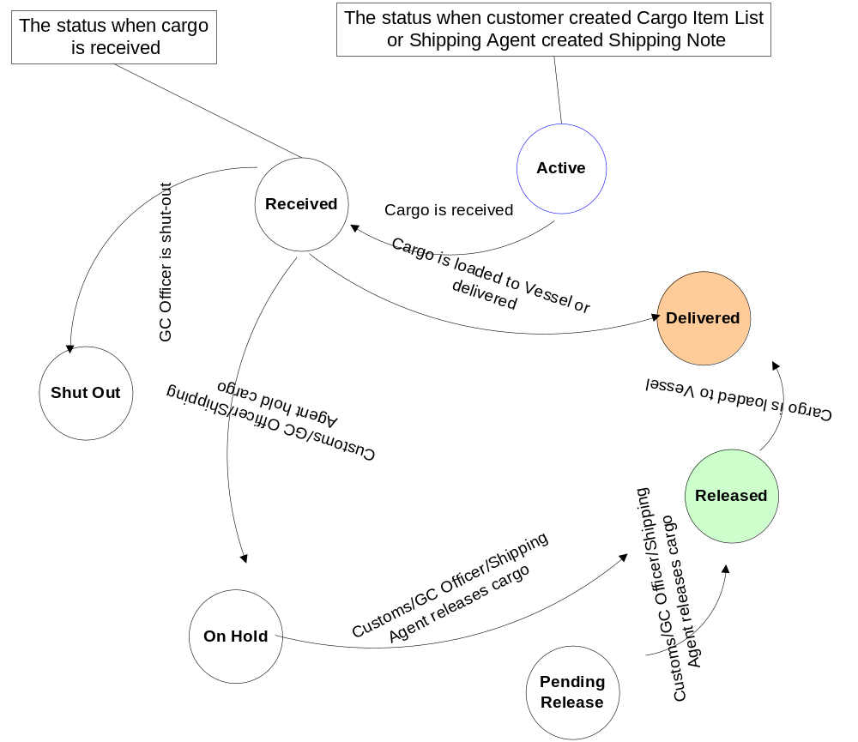
Figure 2: Status Diagram of Cargo Item

 | Status | Description
 | Active | The initial status of cargo item when it is added to Shipping Note
 | Shut Out | Cargo item has been shut out
 | Delivered | Cargo item of Export Booking have been loaded or cargo item of Storage Order is delivered
 | Received | Cargo items have been received.
 | Pending Release | Shipping Agent requests for releasing when all hold reasons are cleared.
 | Released | Cargo item has been released by Customs, GC Officer, or Shipping Agent

Export Booking Status
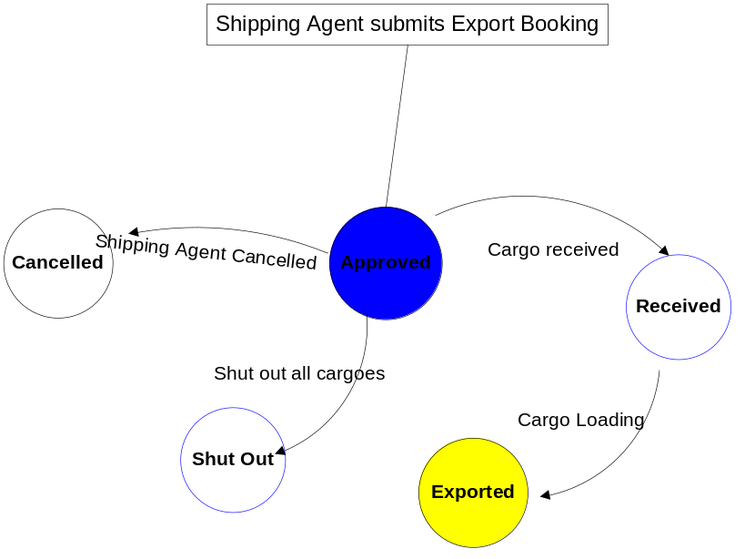
Figure 3: Status Diagram of Export Booking

 | Status | Description
 | Approved | The initial status of Export Booking when Shipping Agent submits Export Booking
 | Cancelled | Export Booking is in cancelled status when Shipping Agent cancels Export Booking
 | Shut Out | Export Booking is changed to this status When all cargo items in Export Booking are shut out
 | Exported | All cargo items of Export Booking have been loaded to vessel.
 | Received | Cargo items have been received.

Security Matrix
See GCS_SecurityMatrix.xls document enclosed with SRS package

Constraints
Currently, Cargo, Tariff, and labor information is available in Dubai systems. GCS system needs to get this information from the available systems, not manage this information in GCS database.

Assumptions & Dependencies

- GCS system will be integrated with Labor Management System (LMS) to get labor information and to update the Labor working status in LMS system.
Therefore, it is assumed that LMS will be available for integration before 15-Sep-2008. If LMS is delivered later on 15-Sep-2008, GCS will not be available for testing the gang functionalities.

- GCS system will be integrated with MDS system to get the information of Cargo and Tariff schema.

Entity relation Model

Entity Diagrams
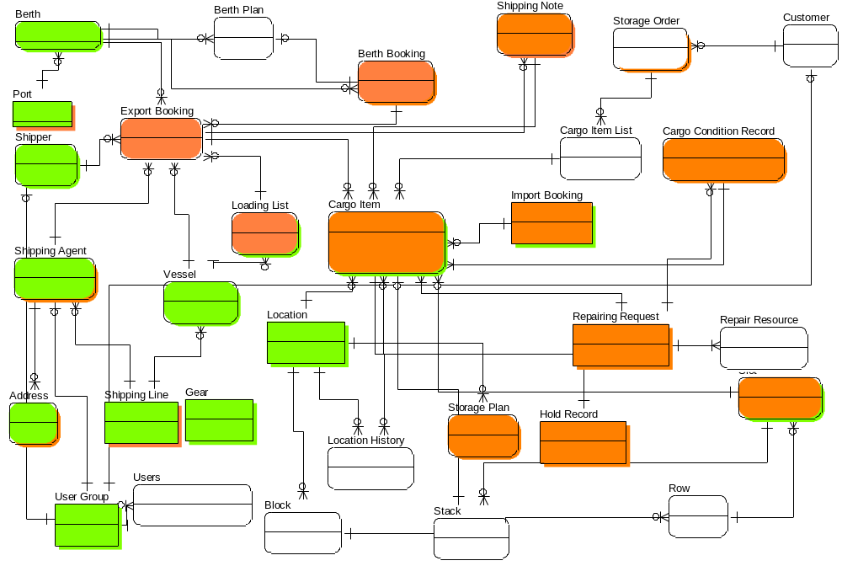

Figure 1: Logical View of Entity Relationship Diagram

# | Entity Name | Description
 | User Group | User Group information
 | Shipping Agent | Shipping agent information
 | Shipper | Shipper’s information
 | Address | Address information of Shipping agent, Shipper.
 | Export Booking | Export Booking information
 | Shipping Note | Shipping Note & Tally Sheet information
 | Cargo Item | Cargo item information
 | Loading List | Information of Loading List of Cargo
 | Vessel | Information of Vessel
 | Shipping Line | Shipping Line attribute information
 | Berth | Berth information of general cargo
 | Berth Booking | Berth Booking information of general cargo
 | Berth Planning | Berth Planning information of general cargo
 | Gear | Gear information of general cargo
 | Hold Record | Hold Cargo record information
 | Cargo Condition Record | History of cargo condition
 | Import Booking | Import Booking information of general cargo store
 | Storage order | Storage Order information
 | Cargo Item List | Link entity between Cargo Item and Storage Order
 | User | User Information
 | Location | Information of store of general cargo
 | Slot | Information of slot of general cargo
 | Stack | Stack Information
 | Block | Block information
 | Location History | The movement information of Cargo
 | Repair Resource | Resource information that is prepared for repairing cargo

Entity Details

User Group
 | Attribute | Type | Mandatory | Description
 | User Group ID | Number | PK, Y | The primary key auto generated by the system
 | Group Name | String | Y | It can be GC officer, Shipping Agent, Shipper, Customer...
 | Group Code | String | Y
 | Email address | String | Y
 | Telephone Number | String | N
 | Contact Mobile Phone Number | String | N

Shipping Agent
 | Attribute | Type | Mandatory | Description
 | Shipping Agent ID | Number | PK, Y | The primary key auto generated by the system
 | Agent Code | String | Y | Agent Refer No, This is unique number
 | Agent Name | String | Y
 | Address | String | Y | Agent’s address
 | Email address | String | Y
 | Telephone Number | String | Y
 | Fax Number | String | N
 | Contact Person | String | Y
 | Contact Person Email | String | N
 | Shipper Company | String | Y | Shipper Name defines who are owner of cargos

Shipper
 | Attribute | Type | Mandatory | Description
 | Shipper ID | Number | PK, Y | The primary key auto generated by the system
 | Shipper Name | String | Y
 | Address | String | Y
 | Email Address | String | N
 | Telephone Number | String | N
 | Fax Number | String | N
 | Contact Person | String | Y
 | Contact Person Tel No | String | N

Address
 | Attribute | Type | Mandatory | Description
 | Address ID | Number | PK, Y | The primary key auto generated by the system
 | City | String | N
 | Street | String | N
 | Country | String | Y
 | Post Code | String | Y

Export Booking
 | Attribute | Type | Mandatory | Description
 | Export Booking ID | Number | PK, Y | The primary key auto generated by the system
 | BRN | String | Y | Booking Reference Number. It is used for Shipping Agent. It is a unique key
 | Agent Code | String | Y | It links to Shipping Agent entity. It shows which agent has submitted the Export Booking.
 | Vessel Name | String | Y
 | Rotation No | Number | Y | It is unique for every Voyage No
 | Date of Creation | Date | Y | The submitted date of Export Booking
 | Approved Date | Date | N | The approval date of Export Booking
 | Status | String | Y | It can be Approved, Cancelled, Received, Exported, or Shut Out
 | Gross Volume | Number | Y | Total volume of all cargo items
 | Gross Weight | Number | Y | Total weight of Cargos in Exporting Booking
 | Port of Loading | Number | FK, Y | Link to Port Entity
 | Port of Discharge | Number | FK, N | Link to Port Entity
 | Port of Final Destination | Number | FK, Y | Link to Port Entity
 | Direct Loading? | String | Y | Y/N
 | Cargo Description | String | Y
 | Package Type | String | Y | It can be BDL, BLT, SKID, COLLI, PKG, CRT, UNIT …

Shipping Note
 | Attribute | Type | Mandatory | Description
 | Shipping Note ID | Number | PK, Y | The primary key auto generated by the system
 | Receive Date | Date | Y
 | Actual Received Date | Date | N | Define the actual received date of cargo
 | Received Start Time | String | N | Define start time of cargo is received (format HH24:MM)
 | Received End Time | String | N | Define end time of cargo is received (format HH24:MM)
 | Number of Packages | Number | Y | The planned number of packages for Shipping Note
 | Gross Weight | Number | Y | Total weight of cargo in Shipping Note
 | Gross Volume | Number | Y | Total Volume of cargo in Shipping Note
 | Actual Gross Volume | Number | N | Gross Volume in Tally Sheet
 | Actual Gross Weight | Number | N | Gross value in Tally Sheet
 | Actual Total of Packages | Number | N | Total of package of cargo in Tally Sheet
 | Tally Sheet No | String | N | It is a unique number (?)
 | Tally Remark | String | N
 | No. F/L | Number | N
 | Manpower | Number | N
 | Vehicle No | String | N
 | Direct Loading? | Boolean | Y | Yes/No

Cargo Item
 | Attribute | Type | Mandatory | Description
 | Cargo Item ID | Number | PK, Y | The primary key auto generated by the system
 | Shipping Note ID | Number | FK, Y | Link to Shipping Notes
 | Cargo Name | String | Y
 | Cargo Type | String | Y
 | BRN | Number | FK, Y | Links to Export Booking. It shows which Export Booking the cargo will be included
 | Status | String | Y | Active, Shut Out, Received, On Hold, Pending Release, Released, Delivered.
 | Number of Packages | Number | Y
 | Package Type | String | Y
 | Volume | Number | Y
 | Weight | Number | Y
 | Hazardous Cargo | String | Y | Yes/No. It shows the Cargo is dangerous cargo or not
 | IMO Class | Number | N | Define IMO Class that Cargo is categorized. It only exist when Hazardous Cargo is dangerous
 | UN Number | String | N
 | Required Temperature | String | Y | Required Temperature or not (Yes/No)
 | Degree | Number | N | Define the minimum degree which Cargo required.
 | Actual Receive Date | Date | N | Actual Date cargo received.
 | Receive Start Time | String | N | There is no second in time format (HH24:MM)
 | Receive End Time | String | N | There is no second in time format (HH24:MM)
 | Actual Number of Package | Number | N
 | Actual Weight | Number | N | Received weight
 | Actual Volume | Number | N | Received quantity
 | Good Volume | Number | N | Total good volume of received cargo
 | Slot Number | Number | N
 | Mark & Nos | String | N
 | Commodity Description | String | N
 | Location No | Number | N
 | Vehicle No | String | Y | Truck/Vehicle No

Loading List
 | Attribute | Type | Mandatory | Description
 | Loading List ID | Number | PK, Y | The primary key auto generated by the system
 | Rotation Number | String | Y
 | Date of Creation | Date | Y | Define created date of Loading List
 | Arrival Time | Time | Y
 | Arrival Date | Date | Y
 | Voyage No | String | Y

Location
 | Attribute | Type | Mandatory | Description
 | Location ID | Number | PK, Y | The primary key auto generated by the system
 | Location Code | String | Y | Unique codes for each store
 | Location Name | String | Y | Store Name
 | Location Type | String | Y | It can be Cool store, Cold Store, Open Shed, or Cover Shed
 | Number of Slots | Number | Y | Slot of store
 | Temperature | Number | N | Define the temperature for Cool Store and Cold Store
 | Degree | Number | N | It is required when Store Type is “Cool Store” or “Cold Store”

Slot
 | Attribute | Type | Mandatory | Description
 | Slot ID | Number | PK, Y | The primary key auto generated by the system
 | Slot Number | String | Y | Unique codes for each slot of a store
 | Slot Name | String | Y | Slot Name

Vessel
 | Attribute | Type | Mandatory | Description
 | Vessel ID | Number | PK, Y | The primary key auto generated by the system
 | Vessel No | String | Y
 | Vessel Name | String | Y
 | Shipping Line No | String | FK, Y | Link to Shipping Line entity
 | Door Site | String | Y | Describe the vessel has door on the left or right…
 | Vessel Type | String | Y

Shipping Line
 | Attribute | Type | Mandatory | Description
 | Shipping Line ID | Number | PK, Y | The primary key auto generated by the system
 | Shipping Line No | String | Y
 | Shipping Line Name | String | Y
 | Address | String | Y

Berth
 | Attribute | Type | Mandatory | Description
 | Berth ID | Number | PK, Y | The primary key auto generated by the system
 | Berth Number | String | Y
 | Berth Name | String | Y
 | Berth Side | String | Y

Berth Booking
# | Attribute | Type | Mandatory | Description
 | Berth Booking ID | Number | PK, Y | The primary key auto generated by the system
 | Rotation Number | String | Y | This number is automatically generated by CTMS
 | Berth No | Number | FK, Y | Berth Number links to Berth
 | Status | String | Y | It can be Pending, Approved, Rejected, On-hold
 | Shipping Agent Name | String | Y
 | Vessel Name | String | Y | Vessel Name, It can get from Vessel Master Data
 | Voyage No | String | Y | Voyage No of Vessel
 | ETB | Date Time | N | Estimated Time of Berthing
 | Created Date | Date Time | Y | Date of Creation
 | Time | Time | Y | HH:MM (estimated time of Arrival)
 | Position | String | Y | It defines: Port Side, Starboard Alongside
 | Connection Vessel | String | N | Define the connection vessel name
 | Arrival Draft | Number | Y | The depth of Vessel
 | Ancillary Services | String | Y | Includes: Water supply, Bunker supply, Lay-by
 | General Info | String | N
 | Cargo Description | String | Y | Description of cargo information
 | Dangerous Cargo Declaration | String | Y | Declaration of cargo information in case the cargo is dangerous cargo
 | Gross Weight | Number | Y | Total weight of cargo stored in Vessel that can arrive
 | Gross Volume | Number | Y | Total volume of cargo stored in Vessel that can arrive
 | ETA | Date | Y | Estimated Time of Arrival

Berth Plan
# | Attribute | Type | Mandatory | Description
 | Berth Planning ID | Number | PK, Y | The primary key auto generated by the system
 | Berth No | Number | FK, Y
 | Start Date | Date | Y
 | End Date | Date | Y
 | Start Hour | Number | Y
 | End Hour | Number | Y
 | Rotation No | Number | Y
 | Berthing Side | String | Y
 | Vessel Name | String | Y
 | Quay No | Number | N | Consolidation area
 | Location No | Number | Y | Storage No: Which location cargo is stored
 | From Bollard Number | Number | Y
 | To Bollard Number | Number | Y

Gear
# | Attribute | Type | Mandatory | Description
 | Gear ID | Number | PK, Y | The primary key auto generated by the system
 | Gear Number | String
 | Gear Name | String

Port
 | Attribute | Type | Mandatory | Description
 | Port ID | Number | PK, Y | The primary key auto generated by the system
 | Port Number | String | Y
 | Port Name | String | Y
 | Location | String | Y

Hold Record
 | Attribute | Type | Mandatory | Description
 | Hold Record ID | Number | PK, Y | The primary key auto generated by the system
 | Cargo Item ID | Number | Y
 | Hold Date | Date | Y
 | Release Date | Date | N
 | Hold By | String | Y | Define who has held cargo (Shipping Agent, Customs, or GC Officer)
 | Reason | String | Y | There are two reasons for holding cargo

Customer
 | Attribute | Type | Mandatory | Description
 | Customer ID | Number | PK, Y | The primary key auto generated by the system
 | Customer Name | String | Y
 | Email Address | String | N
 | Fax Number | String | N
 | Contact Phone Number | String | N
 | Address | String | Y

Import Booking
 | Attribute | Type | Mandatory | Description
 | Import Booking ID | Number | PK, Y | The primary key auto generated by the system
 | Import Booking No | String | Y
 | Date of Creation | Date | Y
 | Shipper Name | String | Y

General Reference
 | Attribute | Type | Mandatory | Description
 | Code | Number | PK, Y | The primary key auto generated by the system
 | Name | String | Y
 | Description | String | N

Repairing Request
 | Attribute | Type | Mandatory | Description
 | Repair Request ID | Number | PK, Y | The primary key auto generated by the system
 | BRN | String | N | Required if repairing request is for Export Booking
 | Storage Order No | String | N | Required if repairing request is for Storage Order
 | Location No | Number | Y | Link to Location Entity. It defines where the damaged cargo is
 | Start Date | Date | Y | Repairing start date
 | Time | Time | Y | Repairing start time
 | Self Repair | String | Y | Yes/No: Define whether agent self repair for need port repairing cargo
 | Remark | String | N

Cargo Condition Record
 | Attribute | Type | Mandatory | Description
 | Cargo Condition Record ID | Number | PK, Y | The primary key auto generated by the system
 | Cargo Item ID | Number | FK, Y | Link to Cargo Item
 | Package Type | String | Y
 | Number of Packages | Number | Y | Quantity of cargo
 | Volume | Number | Y
 | Weight | Number | Y
 | Status | String | N | Damaged, Good
 | Location No | Number | N
 | Record Date | Date | Y
 | Reason | String | Y | The reasons for damaging cargo

Storage Order

 | Attribute | Type | Mandatory | Description
 | Storage Order ID | Number | PK, Y | The primary key auto generated by the system
 | Storage Number | String | Y | It is unique for one Customer
 | Cargo Description | String | Y
 | Cargo Type | String | Y
 | Hazardous Cargo | String | Y | Yes/No
 | IMO Class | String | N | Required if Hazardous Cargo is “Yes”
 | UN Number | String | N | Required if Hazardous Cargo is “Yes”
 | Status | String | Y | Pending, Approved, Rejected, Received, Delivered, Exported
 | Gross Weight | Number | Y | Define the total Weight of cargo in storage order
 | Gross Volume | Number | Y
 | Package Type | String | Y
 | Receive date | Date | Y

Cargo Item List
 | Attribute | Type | Mandatory | Description
 | Cargo Item List ID | Number | PK, Y | The primary key auto generated by the system
 | Receive Date | Date | Y
 | Actual Received Date | Date | N | Define the actual received date of cargo
 | Received Start Time | String | N | Define start time of cargo is received (format HH24:MM)
 | Received End Time | String | N | Define end time of cargo is received (format HH24:MM)
 | Number of Packages | Number | Y | The planned number of packages for Shipping Note
 | Gross Weight | Number | Y | Total weight of cargo in Shipping Note
 | Gross Volume | Number | Y | Total Volume of cargo in Shipping Note
 | Actual Gross Volume | Number | N | Gross Volume in Tally Sheet
 | Actual Gross Weight | Number | N | Gross value in Tally Sheet
 | Actual Total of Packages | Number | N | Total of package of cargo in Tally Sheet
 | Tally Sheet No | String | N | It is a unique number (?)
 | Tally Remark | String | N
 | No. F/L | Number | N
 | Manpower | Number | N
 | Vehicle No | String | N

User
 | Attribute | Type | Mandatory | Description
 | User ID | Number | PK, Y | The primary key auto generated by the system
 | Account Name | String | Y | It is unique for the system
 | First Name | String | Y
 | Last Name | String | Y
 | Description | String | N
 | External | Boolean | Y | Yes/No
 | Group Code | String | Y | Code of Shipping Agent, GC Officer, GC Manager, Shed Clerk, Tally Clerk…
 | Tel Phone Number | String | N

Stack
 | Attribute | Type | Mandatory | Description
 | Stack No | Number | PK, Y | The primary key
 | Slot No | Number | Y

Row
 | Attribute | Type | Mandatory | Description
 | Row No | Number | PK, Y | The primary key
 | Block No | Number | Y

Block
 | Attribute | Type | Mandatory | Description
 | Block No | Number | PK, Y | The primary key
 | Location No | Number | Y

Location History
 | Attribute | Type | Mandatory | Description
 | Cargo Item ID | Number | PK, Y | Link to Cargo Item
 | From Location No | Number | FK, Y | Link to Location entity
 | To Location No | Number | FK, Y | Link to Location entity
 | Moved Date | Date | Y
 | Quantity | Number | Y

Repair Resource
 | Attribute | Type | Mandatory | Description
 | Repair Resource ID | Number | PK, Y | The primary key auto generated by the system
 | Repairing Request ID | Number | FK, Y | Link to Repairing Request
 | Number of resources | Number | Y | Number of people or equipment that needs for repairing cargo
 | Type of Resource | String | Y | Define resource is people or equipment
 | Resource Name | String | N | Define name of resource

Functionality Description

Main Functionalities

Below is a list of SRS documents which describe the detailed functional requirements of all the processes
 | Document Name | Description
 | GCS_SRS_EP1&2-ExportBooking_v1.2.doc | This document contains functional requirements of Export Booking & Shipping Notes processes
 | GCS_SRS_EP3-Shut out_v1.1.doc | This document contains functional requirements of Shut Out cargo process
 | GCS_SRS_EP6-ConsolidationOfCargo_v1.1.doc | This document contains functional requirements of Consolidation of Cargo process
 | GCS_SRS_EP13-Hold&Release_v1.1.doc | This document contains functional requirements of Hold & Release cargo process.
 | GCS_SRS_EP7&8_LoadingList&InternalShifting_v1.1.doc | This document contains functional requirements of Loading List process and Internal Shifting process.
 | GCS_SRS_EP15_Berth_Booking_v1.1.doc | This document contains functional requirements of Berth Booking process
 | GCS_SRS_EP13-Hold&Release_v1.0.doc | This document contains functional requirements of Hold & Release cargo process
 | GCS_SRS_EP5-EP11-StorageReceipt_v1.0.doc | This document contains functional requirements of storage receive process
 | GCS_SRS_EP9_CargoMonitoring_v1.0.doc | This document contains functional requirements of cargo monitoring process
 | GCS_SRS_EP12_CargoRepairingRecording_v1.0.doc | This document contains functional requirements of Damaged Cargo Recording process

Common Functionalities

UC C1.1 Search Vessel

Actors
Refer to Security Matrix

Pre-condition
Shipping Agent/internal users has been authorized to use GCS via DP Portal or internal SSO

Mock-up Screen & Data Fields

MOCKUP- Popup Screen

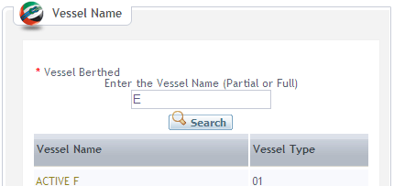

DATA FIELDS

Field name | Mandatory | Control Type | Data Type | Length | Rules
Input
Vessel Berthed | Yes | Text field | Text | 100
Output (The output will be show in grid with following columns)
Vessel Name | Yes | Label | Text | 100
Vessel Type | Yes | Label | Text | 50

Main flows

Step | Action Description | Comment
1 | The user clicks on search icon on parent screens | The user can navigates this function from  - Create Export Booking  - Update Export Booking  - …
2 | The user enters vessel name and then clicks on Search button
3 | The system retrieves all vessels which match with search criteria
4 | The system displays search result on the screen
5 | The user selects one value on the search result | See alternative flow:  A5.1 Close window button
6 | The system closes the popup window and fills vessel name into the Vessel Name text field on the parent screen

Alternatives flows
A5.1 Close window button
Step | Action Description | Comment
5.1.1 | The user clicks on close icon on the top left popup window
5.1.2 | The system closes the popup window and no value is filled into Vessel Name field in parent screen

Business rules
ID | Rule Description | Message ID
C1.1BR1 | The Vessel Berthed needs to be entered partially or fully. The system allows width card search | MS06

UC C1.2 Search Shipping Agent

Actors
Refer to Security Matrix

Pre-condition
Internal users has been authorized to use GCS via internal SSO

Mock-up Screen & Data Fields

MOCKUP- Popup Screen

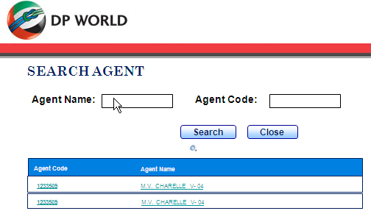

DATA FIELDS

Field name | Mandatory | Control Type | Data Type | Length | Rules
Input
Agent Name | Yes | Text field | Text | 50
Output (The output will be show in grid with following columns)
Agent Code | Yes | Label | Text
Agent Name | Yes | Label | Text

Main flows

Step | Action Description | Comment
1 | The user clicks on search icon on parent screens | The user can navigates this function from  - Generate Export Booking Report
2 | The user enters agent name or agent code and then clicks on Search button
3 | The system retrieves all Shipping Agents which match with search criteria
4 | The system displays search result on the screen
5 | The user selects one value on the search result | See alternative flow:  A5.1 Close button
6 | The system closes the popup window and fills vessel name into the Vessel Name text field on the parent screen

Alternatives flows
A5.1 Close button
Step | Action Description | Comment
5.1.1 | The user clicks on Close button on the popup window
5.1.2 | The system closes the popup window and no value is filled into Vessel Name field in parent screen

Business rules
ID | Rule Description | Message ID
C1.2BR1 | The Agent Name or Agent Code needs to be entered partially or fully. The system allows width card search | MS06
C1.2BR2 | The system accepts all character types of Agent Code & Agent Name

NON-Functional Requirements

Availability
The GC system needs to be available 24x7, in line with the other related systems on DP World infrastructure
It must be available all the working time, and can be down in the off-time for maintaining. This section does not include the availability of network system and other things that GCS Servers depend on.
All the functional components must be available in the same time. Depend on the deployment topology; we will have the detail availability criteria.

Supportability
All predefined values (amounts, dropdown values) must be easy to maintain, i.e. change/update and delete/add (where applicable). All the dropdown values can be upgraded in the period of one day without any shutdown. All the changed dropdown values before one specific time (the midnight,…) can be displayed in the GUI after that time. Other should be done in the downtime.
As wordings are critical, all displayed text (error messages, labels, captions, information messages) must be easy to maintain, i.e. change/update and delete/add (where applicable). All the change for displayed text should be done in the downtime.
The software deployment and upgrade will be specified in the Installation Guide documents.

Performance Requirements

System Throughput
- The system must be capable of scaling up-to 200 users with the addition of faster or greater capacity hardware without software changes. It can support for 120 concurrent logged users into the system.
- The system must be able to process and still meet the response-time targets up-to a maximum of 10000 user-transactions per day for insert, update, & query transactions.
- The system must be able to process and still meet the response-time targets (see below) for up-to a maximum of 30 user-transactions per second for normal function and sustained for at least 5 minutes.

Response Time
All user commands and functions must complete and return control to the user within period defined in the following table. These requirements are defined for local network that has bandwidth >= 1 Gigabit/s and respond times are calculated base on one standard system; it does not include the time data transferred though network devices and wires.

 |  | Function Type | Description | Response Time (seconds)
 | Data Validation |  | The system validates data | 2
 | Simple |  | The function has < 2 transactions per request | 3
 | Medium |  | The function has >=2 and < 4 transactions per request | 5
 | Complex |  | The function has >=4 and < 6 transactions per request | 8
 | Very Complex |  | The function has >=6 and < 8 transactions per request | 12

Data Volume
The system must support for the following data volume on the defined hardware

 | Table Type | Description | Number of records/year
 | Small table | Number of records in this tables < 10000 | 5000
 | Medium table | Number of records in this table > 10000 and < 100000 | 20000
 | Large table | Number of records in this table >100000 and <400000 | 100000
 | Very Large table | Number of records in this table >400000 and <900000 | 300000

The system needs to support for the volumes of business entities
 | Business Entity | Average number of new records/Day | Average Number of new records/year
 | Discharge Tally Sheet | 200 | 73000
 | Loading Tally Sheet | 200 | 73000
 | Storage Receive Tally Sheet | 200 | 73000
 | Export Booking | 200 | 73000
 | Storage Order | 200 | 73000
 | Berth Booking | 150 | 54750
 | Loading List | 200 | 73000
 | Delivery Order | 200 | 73000
 | Import Manifest | 200 | 73000

User Interface
All above performance requirement should guarantee for following client environment:
PC OS: Windows 2000, Windows XP SP2
Browsers: IE 6.0 and up. The screen design follows ITC’s guideline in “Sample UI” provided by ITC and the system needs to be designed to support for the resolution of screen is 1024 x 768

Design Constraints

Date/Time Format
Default date format is dd-mm-yyyy For example: 10-05-2008
Default time format is HH24:MM For example: 17:23

Number Format
Decimal places of % is 1 For example: 25.7%
Decimal for volume and weight is 1 For example: 2.2
Currency format is ##,###,##0.00 (# is digit)

Multi Language
The system will be implemented to support for English only. The system should support for internationalization & multiple locations in future.

Auditing
The system needs to support for auditing sensitive data. The sensitive data will be defined by ITC/DW basing on logical model of Entity diagram

Page size
The system should be designed and developed to generate HTML page size less than or equal to 30KB, except for some special cases.

Modularity
The system should be designed into two (Dubai Trade, Back office) modules. The system needs to support for upgrading system module separately when one module is upgraded, it will not impact on the other modules.

Others
The system should be designed work irrespective of any settings on the client workstations in which IE6.0 or above has been installed and run properly.

Usability
Follow ITC’s guideline of screen design in “Sample UI” provided by ITC

Reliability
The available time is approximately 99% and must be available 24 hours a day, 7 days a week. The GCS should be available in line with other related systems (DT, Custom, Database backend and Java servers) on Dubai Port World infrastructure.

Scalability
GCS system should be designed and developed so that system can be deployed in the clustering & load balancing servers – for database, business server and web server.

Security
The system uses Oracle Single Sign-On & Oracle JAAS framework for authenticating & authorizing. The authorization will base on Security matrix which will define the authorization & roles for the users to be provided by FPT and signed off by ITC/DPW after SRS has been completed.
Authorization and authentication need to be applied in every layers of application using data encryption and SAML token.

Database should provide the capability of data protection from unauthorized users and application. But this option can be done though the capability of Oracle Database 10g, 11g and DBA’s configuration, so this option can be considered as out of scope for development.
GCS will be developed in J2EE Web Application so that it will not support for security at row data level on the screen. The authorization of the system will be at screen/feature level.

Archive & Purging
GCS will not support for the features for archiving & purging data. This task will be done by DBA. DBA will base on the actual data volume of the system to define the methodology to archive and purge data.

Hardware/Software Requirements
These hardware requirements are based on hardware requirements of Oracle Database and Oracle BPEL. The hardware requirements should be changed according to the actual through put of the system. The detailed information of hardware configuration will be described in Infrastructure Design.

Hardware/Infrastructure Requirements
# | Name | Configuration | Purpose
 | Oracle Database Server | Cluster PC Servers  CPU: Intel Xeon Dual Core >=3.0 * 4  RAM: >=8 GB  HD: >= 160GB (Type: SCSI), 7200 rounds/s and support raid level 5, Clustering | Database Server
 | Oracle Application Server | Cluster PC Servers  CPU: Intel Xeon Dual Core >=3.0 * 4  RAM: >=8 GB  HD: >= 160GB (type SCSI), 7200 rounds/s and support raid level 5, Clustering | Application Server
 | Network Bandwidth | >= 1.0Gbit/s | Local Network Infrastructure
 | Network Card | Giga bit Ethernet | Network device

Software Requirements
# | Name | Version | Purpose
 | Oracle SOA Suite 10G | 10.1.3.1 | Development Framework for the application
 | Oracle Application Server 10G | 10.1.2.1 | Application Server for deploying the application
 | Oracle Internet Directory | 10.1.2.1 | LDAP Server, User Management System
 | Oracle Database Server 10G | 10.1.2 | Database Server
 | Struts | 1.2 | Development & running framework
 | Spring | 2.0 | Development & running framework
 | Jasper | 1.2 | Report framework
 | Apache Log4j | 1.2.13 | Log component for tracing
 | Quartz Scheduler | 1.5.2 | Scheduler framework
 | Jakarta Commons Validator | 1.3.0 | Data validation framework

Purchased Components
Name | Purpose
Oracle Suite 10G (Version Release 10.1.3.1) | Development Framework for the application
Oracle Application Server 10G (Release 10.1.2.1) | Application Server for deploying the application
Oracle Internet Directory | LDAP Server, User Management System
Oracle Database Server 10G(Release 10.1.2) | Database Server

Bugs and Defect Rates
The GCS will be implemented as the requirements defined in SRS documents. The ITC/DW sign off the project if the system passes the following criteria of defects rate when the system has been through UAT phase.

Type of Defect | Description | Number allowed
Fatal | Showstopper - tester cannot proceed with any tests  e.g. system crash | 0
Serious | Tester cannot proceed with any tests on one area of functionality | 23
Medium | The bug does not stop testing - but limits it  e.g. data validation wrong | 60
Cosmetic | The defect is not business logic error, it can be typo text, field length… e.g. screen spelling or error message wrong. | 30

Interface Description

LMS Interface Description

CTMS Interface Description

Appendixes

Common Message Description
Message ID | Message Text | Note
MS01 | Please input at least one criterion to do the search.
MS02 | <% Field Name %> is invalid date format.
MS03 | <% Field Name %> is invalid number format.
MS04 | <% Field Name %> should be greater than <% Field Name %>
MS05 | Are you sure you want to delete?
MS06 | <% Field Name… %> is required.
MS07 | Saved successfully.
MS08 | <% EB/SO … %> has been approved.
MS09 | <% Field Name %> should be greater than <% Field Name %> and less than <% Field Name %>
MS10 | Please select at least one <% Field Name %>
MS11 | <% Field Name %> is invalid time format.
MS12 | No records found.
MS13 | <% Field Name %> should be greater than or equal to <% Field Name %>
MS14 | Updated successfully.
MS15 | Failed to update <% EB/SO… %>.
MS16 | <% EB/SO… %> has been rejected.
MS17 | <% EB/SO… %> has been accepted.
MS18 | You are not authorized to use this feature.
MS19 | Internal server error, please contact with administration at <%Email Address %>.
MS20 | <% Field Name %> should be less than <% value %>
MS21 | <% Value %> is duplicated.
MS22 | <% Field Name %> cannot be greater than <% value %>
MS23 | You cannot <% Shut out, Cancel, Delete %>.
MS24 | <% Field Name %> cannot be in the future.

Classes of IMO
There is the following IMO Class for dangerous cargos:
1 - Explosives
2 - Gases: compressed/liquefied/dissolved under pressure
3 - Flammable liquids
4 - Flammable solids/substances liable to spontaneous combustion
5 - Oxidizing substances and organic peroxide
6 - Poisonous and infectious substances
7 - Radioactive substances
8 - Corrosives
9 - Miscellaneous dangerous substances

Repairing Equipment List
There are the following equipments for repairing damaged cargo
- Forklift 3 T
- Forklift 5 T
- Forklift 12 T
- Forklift 15 T
- Forklift 32 T
- Truck Crane 100T
- Heavy Crane 100T
- Mafi with tractor
- Metal Trapping Machine
- Ropes

Repairing resources (people)
There are the following resource types for repairing Cargo
- Manpower
- Carpenter
- Mechanics

